**Testing Screenshots- Implemented & Running Tests (CHAI, MOCHA)**

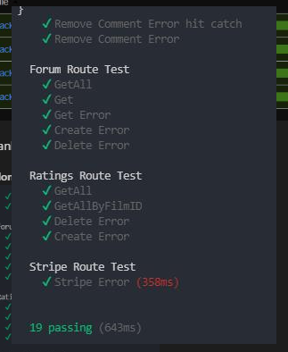

**Testing Coverage Screenshots- Utilised Istanbul for Test Coverage**

